The Bottom Line

Issue 1 Version 2
(flintcares.com)
Should I drink, cook, or brush my teeth with my tap water?
NO!
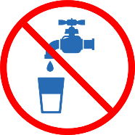

Where do I get bottled water?

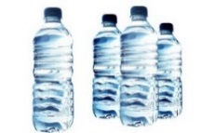
Free bottles of water, filters, replacement cartridges, and home water testing kits are available at water resource sites. These locations do NOT ask for IDs to obtain items. You may be asked for your address to confirm that non-Flint residents are not taking advantage of the Flint water crisis.

IMPORTANT- There are lots of things to remember when using bottled water:

- Keep it out of the sunlight and avoid high heat. If you have to store it outside, it’s best to cover with a tarp or dark cloth.

- Water is heavy! Make sure you don’t stack too high and be sure your floor joists are strong enough to handle the weight.

- Do not drink bottled water after it has been opened and in heat for a long time. Bacteria can grow once a bottle is open and heat makes it grow faster!

- Be sure to rotate your stock! It’s best to use the water you’ve had the longest first.
Water Resource Sites

Sites below are open:
Monday, Wednesday, Thursday and Saturday:
Noon – 6 p.m.
Tuesday and Friday: Noon – 8 p.m

Ward 1:
Genesee County Land Bank
Ross Plaza, 2320 Pierson Road

Ward 3:
Universal Systems
1401 E. Stewart Avenue

Ward 6:
West Court Street Church of God
2920 W. Court Street

Ward 7:
Dort Federal Credit Union
Event Center
3501 Lapeer Road

Ward 9:
Genesee County Land Bank
Eastown Bowl Bowling Alley
3001 S. Dort Highway

Many churches and organizations do water deliveries throughout the City. For more information, please dial 2-1-1. Or, you may call 866-561-2500, if your phone will not dial 2-1-1.

Are the filters safe?
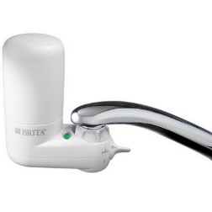

- The EPA, State of Michigan and City of Flint all say the NSF-53 certified filters are safe for filtering out lead below 150 parts per billion and other minerals.
- These minerals and chemicals can be found on the manufacturer’s box. EPA’s data also shows that the filters are working at higher levels above 150ppb.
Caution
- Some experts say while the filter may filter out 99% of the lead, we aren’t sure what else is in the water – chemicals, bacteria, etc.
- These individuals would say until further testing is complete people should use bottled water
- All agree that unfiltered water is not safe to drink, cook or brush teeth.
- Pregnant and nursing women, children under the age of 6 should only use bottled water for drinking, cooking, washing children’s dishes, bottles, pacifiers and for mixing infant formula.
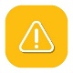

Do your research, listen to trusted sources and use either filtered or bottled water.

If you do not have a water filter and would like one,
you may call 2-1-1.

How do I use the filter?

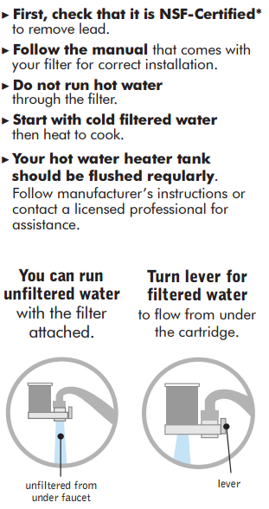
*National Sanitation Foundation
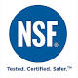

Why can’t I run hot water
through my filter?

Per the manufacturers:

If hot water is run through the cartridges, it will not be adequately filtered

IN SOME CASES MAY ACTUALLY REVERSE THE CHEMICAL ABSORPTION AND ADSORPTION PROCESSES, RELEASING CONTAMINANTS BACK INTO THE WATER.

USE ONLY COLD OR COOL WATER WHEN OPERATING THE FILTERS.

If you happen to accidentally run hot water through the system, simply run cold water through the unit for 2 minutes to flush out the hot water.

With regard to whole house systems, you will still get clean filtered hot water because the cold water line of your home will connect to the filter system, get filtered first and then will go to the hot water heater to be heated.

