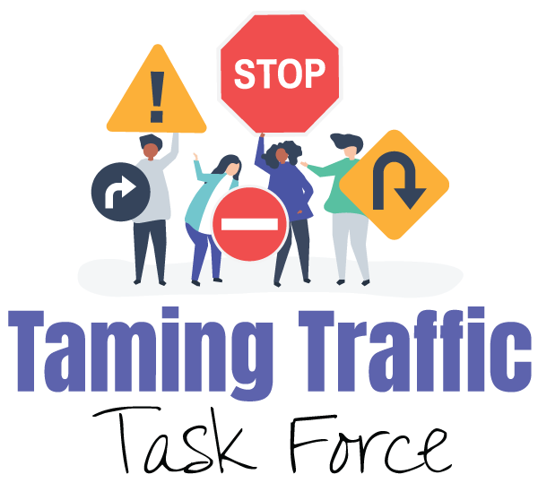

Dear City of Flint Resident,

I’m writing to you today because October 2020 is “Distracted Driving Month.” Texting or using a hand-held phone while driving is a leading distraction that causes traffic crashes.
Nationally distracted driving kills over 3,000 people a year and injures hundreds of thousands more. Research shows that 25% of teens respond to texts at least once every time they drive and often more (University of Michigan Transportation Research Institute).
Speeding increases the risks from distracted driving. Walkers, children, and cyclists in Flint’s neighborhoods are vulnerable.
As a Flint resident I am concerned because . . .
{please share your personal experience here}
This is why I urge you to sign the pledge NOT to drive distracted! Set your phone to silent when driving. Remind friends and family to do so too.
Sincerely,
{insert name here}
To sign the Anti-Distracted Driving Pledge copy the following link and paste it in your browser:
https://docs.google.com/forms/d/e/1FAIpQLSewSPvA6vGAIV5IapYGE8oKTs93x4GUTUHb3nV6U3lACObjpw/viewform

